TOWN OF SOLON, MAINE
Request for Bids for a Roof over the Handicap Ramp

The Town of Solon, Maine is requesting bids for building a roof over the handicap ramp going to the conference room on the east side of the Town Office.

Bids are due no later than 5:00 pm on May 7, 2025 at Solon Town Office at the address below and should be marked “Town Office Ramp Roof Bid.”

Town of Solon
Attn: Select Board
121 S Main St.
PO Box 214
Solon, Maine 04979

Bid packets are available at Solon Town Office 121 S Main St, on the Town’s website www.solon.maine.gov or via e-mail at townofsolon.assistant@gmail.com.

Bids must be sent through U.S. Mail or Express Mail, or hand delivered, e-mailed, or faxed to 207-643-2864. Proposals received after the deadline will not be accepted.

The Town is not liable for any cost incurred by the bidder in connection with the preparation of submission of a proposal. The Town of Solon, Maine reserves the right to accept any proposal and to reject any and all proposals.

Bids will be opened publicly at the Solon Select Board meeting on Wednesday, May 7, 2025, 5:00PM at the Solon Town Office, 121 S Main St., Solon, ME. Additional information or clarification can be obtained by contacting the Solon Select Board at 207-643-2541.

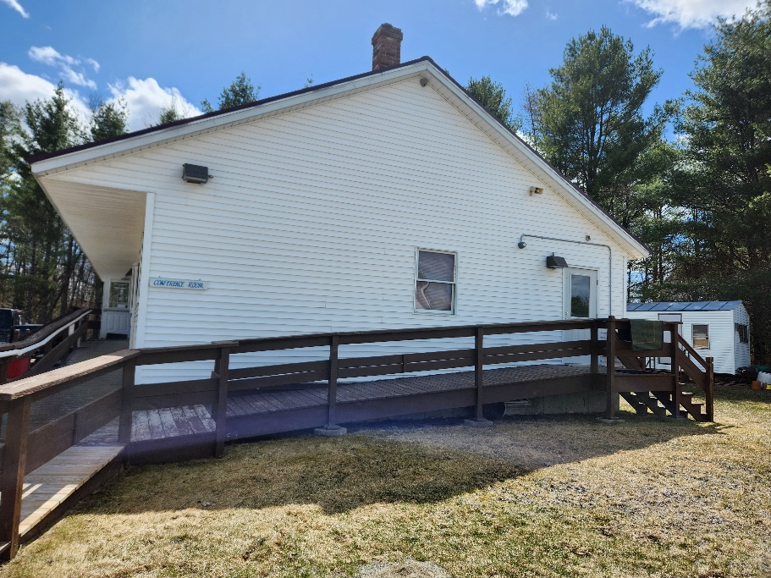
- Overview: This request seeks bids for installing a roof over the handicap ramp on the east side of the Town Office. The roof will be approximately 35’ long by 5’ wide and will be a metal roof to match the current roof on the Town Office. Page one shows a picture of the east side of the building.

- Duration of the Contract: This contract will cover a period becoming effective May 8, 2025, through September 30, 2025.

- Reservation of Rights: The Town reserves the right to request clarification of and/or solicit additional information of any proposer; to have proposer(s) make presentations to the Select Board; and/or to negotiate with any proposer(s) regarding any terms of their bid, with the intent to achieve a bid that is deemed by the Town to be in its best interests. The Town reserves the right to substantiate the proposer’s qualifications, capability to perform, availability, past performance record and to verify that the proposer is current in its obligations. The Town of Solon reserves the right to reject any and all proposals, to waive any irregularities at its sole discretion, and to accept any proposal that it deems to be in its best interests. Any submissions received after the deadline may be rejected.

- Bid Format Requirements: Bids must be presented using the attached Official Bid Response Form. The proposal shall respond to all requirements of this request. Any exceptions to the specifications of this request must be clearly stated in writing in an attached letter.

- Insurance Requirements: The successful bidder must furnish evidence of a valid Certificate of Liability Insurance prior to the work commencing. The Town of Solon must be named as an additional insured. The successful bidder must also provide proof of Workers Compensation Insurance for all employees on the job per statutory limits or verification of Independent Contractor Status.

- Contract Terms:
6.1. The contract will cover a period becoming effective May 1, 2025 through September 30, 2025. A valid Certificate of Liability of Insurance will be required annually.
6.2. Breach of any contract condition may give rise to contract cancellation at the option of the Solon Select Board.
6.3. The Town of Solon reserves the right to terminate this contract at any time with 30 days written notice provided by Certified Mail if the Select Board has reason to believe the contractor is not performing satisfactorily.
6.4 The Town of Solon reserves the right to extend this contract for one (1) additional year.
6.5. The contract cannot be assigned, transferred or sublet at any time without prior approval of the Select Board.
6.6. Payment will be made by invoice on a monthly basis to the Town of Solon, Treasurer.
6.7 All required work being performed within this contract will be under the direction and reviewed by a select board member.
6.8. Variances from these specifications will be considered a breach of the contract. All services shall be performed in a neat, workman-like manner, subject to the approval of the Select Board

- Obligations of Contractor
7.1 The Contractor will be required to have all implements necessary to execute the obligations of work being performed under this contract.
7.2 The Contractor will clean the area upon completion of the job.
7.3 The Contractor shall not provide any service outside this contract without the prior approval of the Select Board.

Bids for a Roof over the Handicap Ramp at the Solon Town Office
OFFICIAL BID RESPONSE FORM

The UNDERSIGNED hereby declares that he/she or they are the only person(s), firm or corporation interested in this proposal as principal, which it is made without any connection with any other person(s), firm or corporation submitting a proposal for the same. The UNDERSIGNED hereby declares that they have read and understand all conditions as outlined in the bid request and that their proposal is made in accordance with same. The UNDERSIGNED hereby declares that any person(s) employed by the Town of Solon, Maine, who has direct or indirect personal or financial interest in this proposal or in any portion of the profits that may be derived there from, has been identified and the interest disclosed by separate attachment. (Please include in your disclosure any interest which you know of. An example of a direct interest would be a Town employee who would be paid to perform services under this proposal. An example of indirect interest would be a Town employee who is related to any officers, employees, principal, or shareholders of your firm or to you. If in doubt as to status or interest, please disclose to the extent known).

COMPANY NAME: ____________________________________________________________________
(Circle One: Individual, Partnership, Corporation, Joint Venture)

PRINT NAME & TITLE: _________________________________________________________________

(Officer, Authorized Individual or Owner)
ADDRESS: ____________________________________________________________________________________

E-MAIL: _____________________________________________________________________________

TELEPHONE: _________________________________ FEDERAL TAX ID: _______________________

NOTE: All bids must bear the handwritten signature of a duly authorized member or employee of the organization making the bid. This sheet must be signed and returned with the proposal package.

- Solon Town Office (121 S. Main St., Solon, Maine)
- Build an approximate 35’ long x 5’ wide roof over the handicap ramp on the east side of the town office

Total Bid Price:

AUTHORIZED
SIGNATURE: _______________________________________________ DATE: ___________________

